You are invited to the Decatur Illini Club’s
30th Annual Corn Roast!!!
Monday, August 15, 2016
Knights of Columbus Hall, Downtown Decatur
5:30 – 8:00 (doors open at 5PM)
Featuring University of Illinois Athletic Director,
Josh Whitman
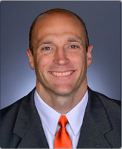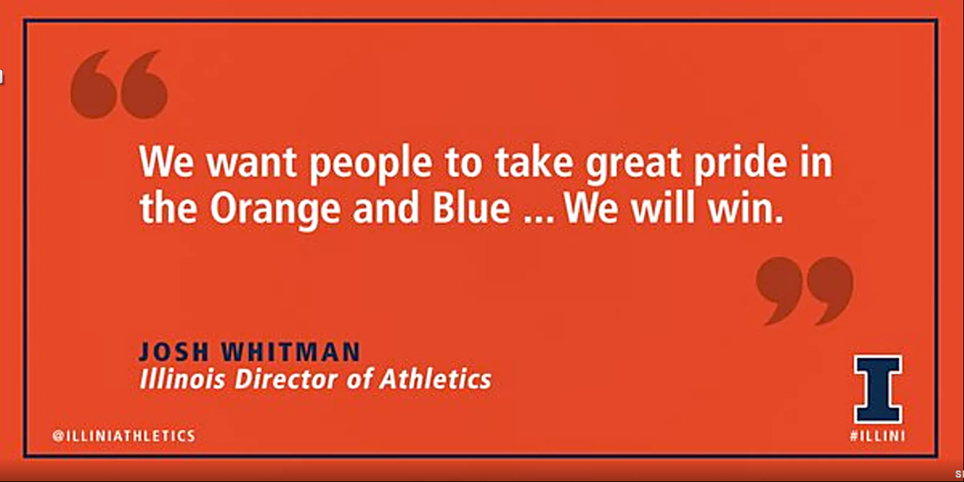
Your emcee for the evening: Matt Hall from NowDecatur.com
Event will include:
- Full meal including soft beverages
- Presentation of our 2016 Scholarship Award
- Raffle featuring many wonderful Illini prizes
*All proceeds benefit the Decatur Illini Club scholarship fund
Tickets only $20 per person!
R.S.V.P. by: August 10, 2016

Please complete the form below and send your check payable to “Decatur Illini Club” to
Jen Wood @ 4472 Hale Dr. Decatur, IL 62526
If you have questions,
Call Jen at 217-413-1103 or email at: decaturillini@gmail.com
Please reserve_____ place(s) at $20.00 each for the 2016 Corn Roast on August 15, 2016.
____ I am also including my Annual Local Membership Dues of $20 per family.
In an effort to keep our membership list up to date, please take a moment to update your contact information: Name: ____________________________________
Address: ____________________________________
____________________________________
Household e-mail address: ____________________________________

